CS 255 System Design Document Template

This template lays out all the different sections that you need to complete for Project Two. Each section has guidance to prompt your thinking. You will need to continually reference the interview transcript as you work to make sure that you are addressing your client’s needs. There is no required length for the final document. Instead the goal is to complete each section based on what your client’s needs are. Remove this note when you are finished, and replace all bracketed text with the relevant information.

UML Diagrams

UML Use Case Diagram
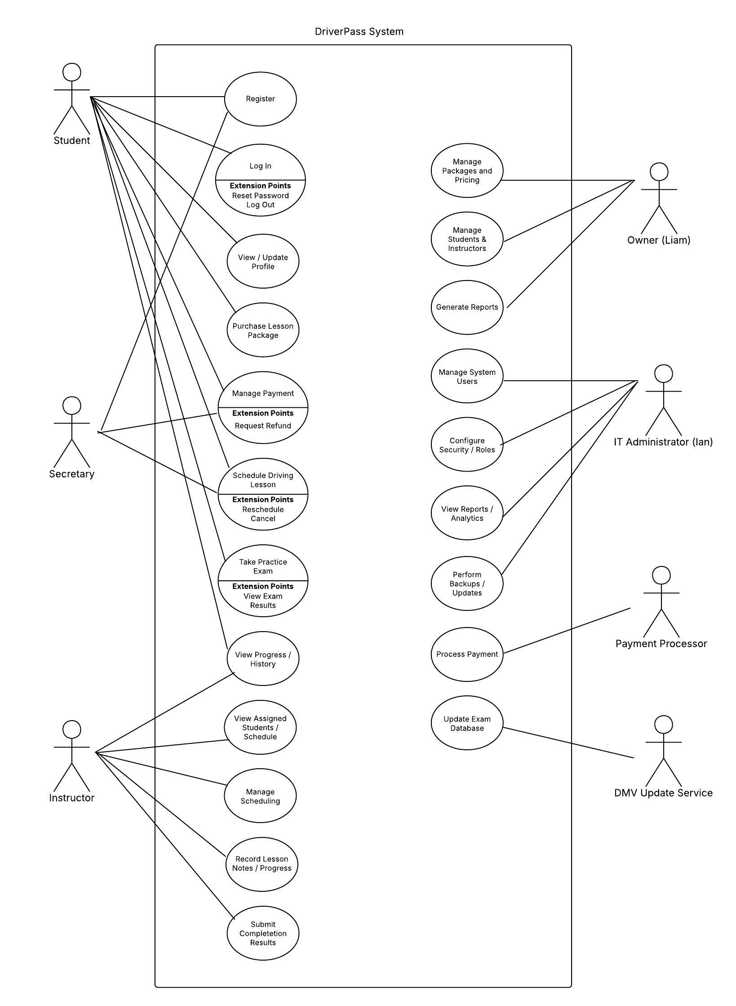

UML Activity Diagrams

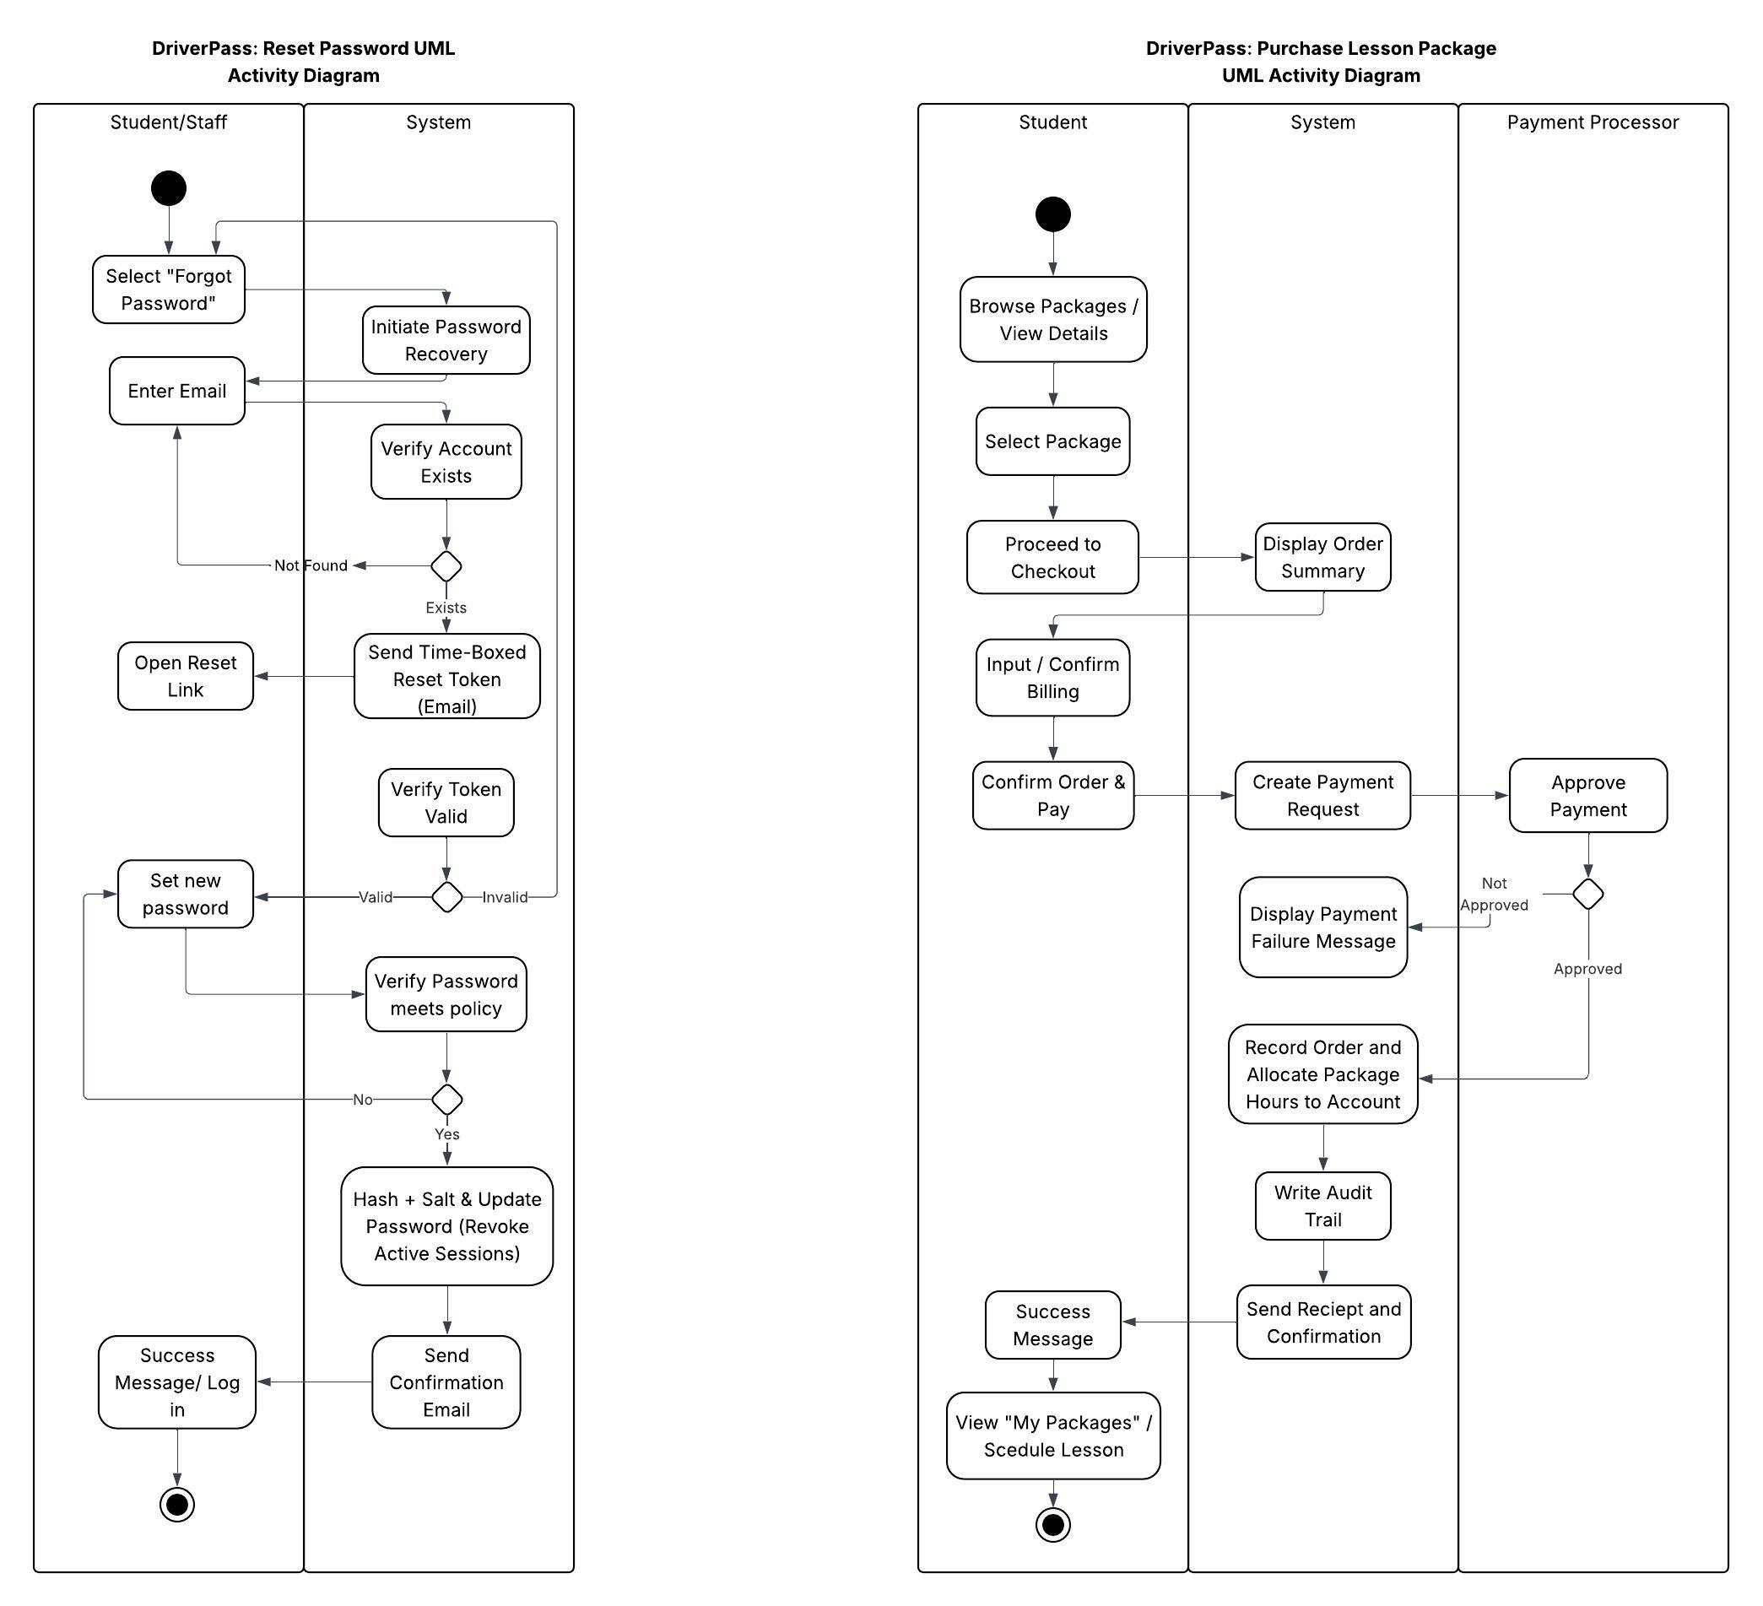

UML Sequence Diagram

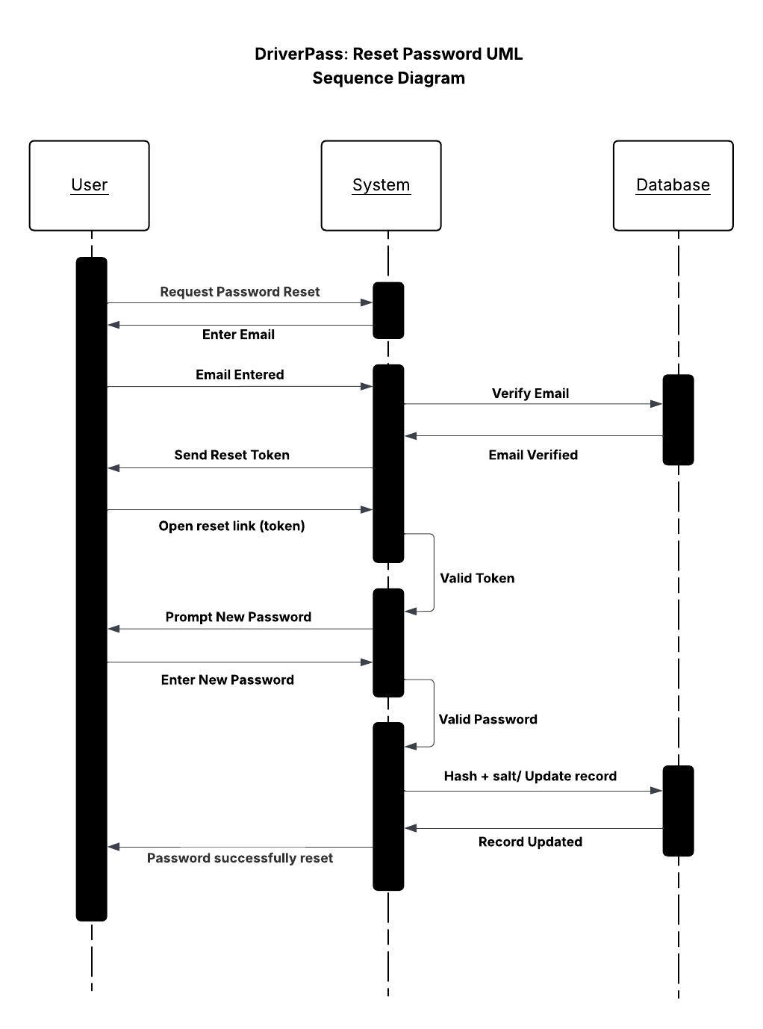

UML Class Diagram

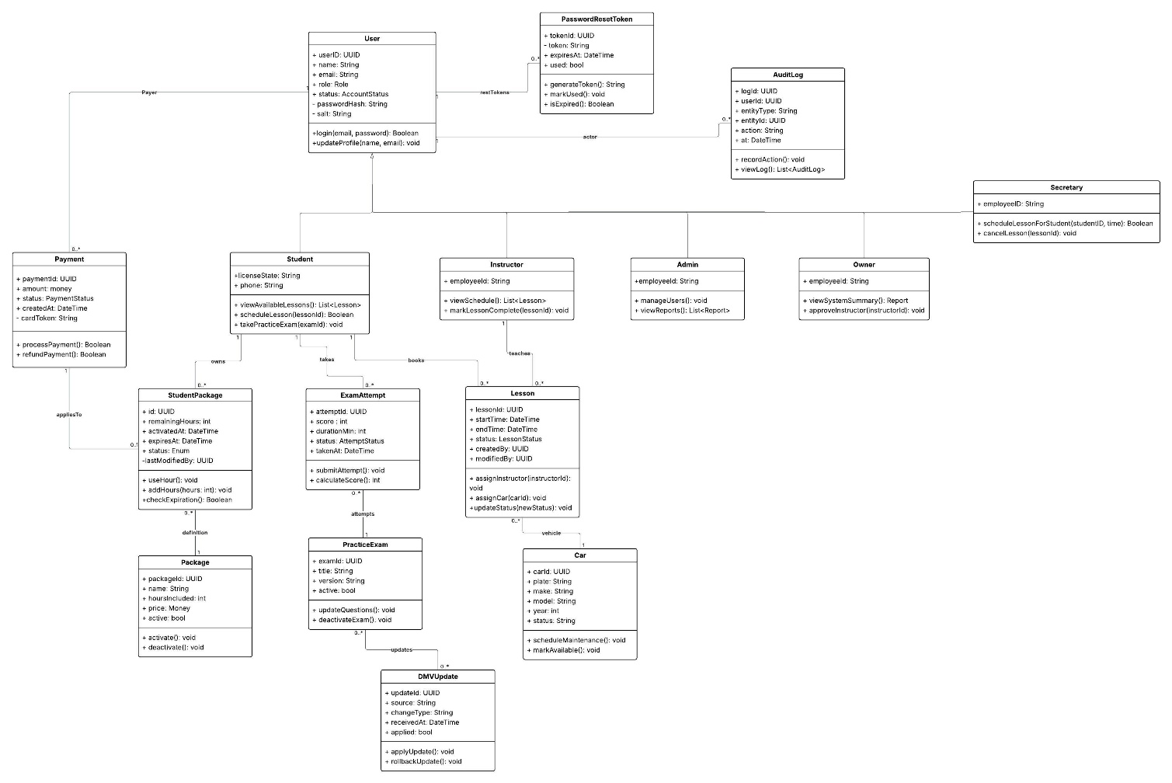

Technical Requirements
The technical requirements for the DriverPass system are derived from the functional and nonfunctional requirements identified in the Business Requirements Document and reflected in the UML diagrams created for the system. These requirements specify the hardware, software, tools, and infrastructure needed to implement the design features shown in the system models.

Hardware Requirements
- The DriverPass system will be hosted on a cloud platform such as AWS or Azure to ensure 99.9% uptime and remote accessibility for students and staff, as identified in the BRD.
- Servers will host both the web application and the relational database that supports user accounts, lessons, payments, and exam attempts.
- The hosting environment will include:
  - Application servers that handle authentication, scheduling, payment processing, and reporting logic (as shown in the class diagram through classes like Lesson, Payment, and AuditLog).
  - Database servers to store persistent data for User, StudentPackage, Lesson, and PracticeExam.
  - Storage volumes for static files such as course materials and DMV exam data.
- Cloud auto-scaling and load balancing will maintain fast performance during peak demand.

Software Requirements
- Front-End Software:
A responsive web interface built with HTML5, CSS, and JavaScript to allow users to log in, schedule lessons, take exams, and make payments from any device.
The interface connects to the back end through secure REST APIs, as modeled in the sequence and activity diagrams.
- Back-End Software:
A server-side application (implemented in Java, Python, or Node.js) that performs business logic for user management, lesson scheduling, payments, and exam processing.
  - Handles password reset flows (shown in the sequence diagram).
  - Enforces role-based access control (students, instructors, secretaries, admins, owners) defined in the use case and class diagrams.
  - Logs every change in the AuditLog class.
- Database Management System:
A relational database (MySQL or PostgreSQL) used to store entities from the class diagram: User, Lesson, Car, Package, Payment, ExamAttempt, and others.
Relationships between these entities mirror the associations in the UML class diagram.
- Security Framework:
Implements secure authentication and password hashing (bcrypt or Argon2), encrypted communication (TLS 1.2+), and data validation to meet the nonfunctional requirements for security, reliability, and privacy in the BRD.
Password reset functionality, token validation, and session management directly support the PasswordResetToken class and related sequence flow.
- Operating Systems:
Compatible with Windows Server and Linux environments to provide flexibility in cloud deployment.

Tools and Development Environment
- Lucidchart for UML modeling and documentation, as used to create the system diagrams.
- Integrated Development Environment (IDE): Eclipse, IntelliJ IDEA, or Visual Studio Code for coding and debugging.
- Version Control: Git/GitHub for collaborative development and tracking changes.
- Testing Tools: Browser-based testing (e.g., Selenium) for user interface and integration testing.
- Monitoring and Logging: CloudWatch or ELK Stack for real-time performance tracking and logging system events.
- Email and API Services: Used for password reset notifications and DMV update synchronization, as represented in the class diagram’s DMVUpdate and PasswordResetToken classes.

Infrastructure Requirements
- The system follows a three-tier architecture:
  - Presentation Layer: Browser-based front end where users interact with the system.
  - Application Layer: Middleware handling logic for scheduling lessons, managing users, payments, and exams.
  - Data Layer: Relational database storing and securing all persistent information.
- Connectivity: All communications occur over HTTPS with valid SSL/TLS certificates.
- Backup and Recovery: Automated daily database backups with version retention to ensure data recovery and compliance with nonfunctional reliability requirements.
- Scalability: The system supports dynamic scaling to accommodate increasing users or future integration with DMV APIs or a mobile app.
- Access Control: Role-based access enforced in middleware aligns with user roles in the UML class hierarchy.
- Logging and Monitoring: Activity logs and audits generated automatically through the AuditLog class.

